

**First Aid Policy**

**September 2023**

**Henry Hinde School**

**Version Control**

|  |  |  |
| --- | --- | --- |
| **Category:** | Health and Safety | |
| **Authorised By:** | TLET Audit and Risk Committee | |
| **Author:** | A.Wright | |
| **Version** | 4 | |
| **Status:** | Under Review: |  |
| Approved: | ✔ |
| **Issue Date:** | September 2023 | |
| **Next Review Date:** | September 2025 | |
| **Statutory Policy:** | Yes | ✔ |
| No |  |
| ***Printed Copies Are Uncontrolled*** | | |

**Contents**

|  |  |
| --- | --- |
| **Section** | **Page** |
| 1. The TLET Way | 5 |
| 2. Definition of Terms | 6 |
| 3. Rationale and Statutory Requirements | 6 |
| 4. Scope | 7 |
| 5. Principles | 8 |
| 6. Policy Statement | 8 |
| 7. Procedure | 9 |
| 8. First Aid Equipment | 9 |
| 9. Recording and Reporting | 10 |
| 10. Training | 11 |
| 11. Monitoring | 12 |
| 12. Related Documents | 12 |
| Appendix 1 - List of Appointed Persons and trained First Aiders | 13 |
| Appendix 2 - Accident Report Form | 14 |
| Appendix 3 - First Aid Training Log | 15 |

**1 – The TLET Way**

Transforming Lives Educational Trust (TLET) is a family of academies. Every TLET policy is rooted in and reflects our ambitions for pupils, students and wider stakeholders alike. Our ambitions are to **Nurture Potential, Inspire Community and Deliver Excellence.**

Through the transformative values of **courage, kindness** and **loyalty** we:

* Nurture Potential - We flourish in the places we create together.
* Inspire Community - We champion each other to make a difference.
* Deliver Excellence - We strive to achieve our best.

**2 – Definition of Terms**

2.1 **First Aider**, in the context of this policy, is defined as a member of academy staff designated to be responsible for First Aid, and in receipt of a current First Aid training qualification.

2.2 **Mental Health First Aider**, in the context of this policy, is defined as a member of academy staff designated to be responsible for Mental Health First Aid, and in receipt of a current Mental Health First Aid training qualification.

2.3 **Paediatric First Aider**, in the context of this policy, is defined as a member of staff at an academy with Early Years Foundation Stage provision designated to be responsible for Paediatric First Aid, and in receipt of a current Paediatric First Aid training qualification.

2.4 **Appointed person**, in the context of this policy, is defined as any other member of staff with a responsibility for First Aid, who may or may not be in receipt of a current First Aid training qualification.

**3 – Rationale and Statutory Requirements**

3.1 This policy is based on the [Statutory Framework for the Early Years Foundation Stage (EYFS)](https://www.gov.uk/government/publications/early-years-foundation-stage-framework--2), general advice from the Department for Education on first aid and health and safety in academies, and the following legislation:

* [The Health and Safety (First Aid) Regulations 1981](https://www.legislation.gov.uk/uksi/1981/917/regulation/3/made), which state that employers must provide adequate and appropriate equipment and facilities to enable first aid to be administered to employees, and qualified first aid personnel;
* [The Management of Health and Safety at Work Regulations 1992](https://www.legislation.gov.uk/uksi/1992/2051/contents/made), which require employers to make an assessment of the risk to the health and safety of their employees;
* [The Management of Health and Safety at Work Regulations 1999](https://www.legislation.gov.uk/uksi/1999/3242/contents), which require employers to carry out risk assessments, make arrangements to implement necessary and arrange for appropriate information and training;
* [The Reporting of Injuries, Diseases and Dangerous Occurrences Regulations 2013 (RIDDOR)](https://www.legislation.gov.uk/uksi/2013/1471/contents), which state that some accidents must be reported to the [Health and Safety Executive (HSE)](https://www.hse.gov.uk/), and set out the timeframe for this and how long records of such accidents must be kept;
* [The Social Security (Claims and Payments) Regulations 1979](https://www.legislation.gov.uk/uksi/1979/628/contents), which set out rules on the retention of accident records;
* [The Education (Independent Academy Standards) Regulations 2014](https://www.legislation.gov.uk/uksi/2014/3283/contents), which require that suitable space is provided to cater for the medical and therapy needs of pupils

**4 – Scope**

This policy refers to…… (Tick as appropriate)

|  |  |  |  |
| --- | --- | --- | --- |
| **Parents/Carers** |  | **Trustees** |  |
| **Employees** | ✔ | **Volunteers** |  |
| **Pupils/Students** |  | **Visitors** |  |
| **Governors** |  | **Community** |  |

4.1 **Roles & Responsibilities**

4.1.1 **The TLET Director of Operations** (DoO) is responsible for:

* producing, and annually reviewing, a Trust-wide First Aid Policy template for distribution to the Trust’s academies;
* reviewing First Aid data from each academy as part of the termly Health and Safety meeting with academy representatives.

4.2 **First Aiders, Mental Health First Aiders and Paediatric First Aiders** are trained, qualified and responsible for:

* ensuring there is an adequate supply of medical materials in first aid kits, and replenishing the contents of these kits;
* ensuring that an ambulance or other professional medical help is summoned when appropriate;
* acting as first responders to any incidents, assessing the situation where there is an injured or ill person, and providing immediate and appropriate treatment;
* taking charge when someone is injured or becomes ill;
* sending pupils and staff home to recover, where necessary;
* filling in an accident report on the same day, or as soon as is reasonably practicable, after an incident (see the template in **Appendix 2**).

4.2.1 First Aiders, Mental Health First Aiders and Paediatric First Aiders are listed in **Appendix 1**. Their names will also be displayed prominently around the relevant TLET site.

4.3 **The Governing Board** is responsible for:

* all health and safety matters in the academy. However, the Governing Board delegates operational mattes and day-to-day tasks to the academy Principal.

4.4 **The Academy Principal** is responsible for:

* the implementation of this policy, including:
  + - ensuring that an appropriate number of trained first aid personnel are present in the academy at all times;
    - ensuring that First Aiders, Mental Health First Aiders and Paediatric First Aiders have an appropriate qualification, keep training up-to-date and remain competent to perform their role;
    - ensuring all staff are aware of first aid procedures;
    - ensuring appropriate risk assessments are completed and appropriate measures are put in place;
    - undertaking, or ensuring that managers undertake, risk assessments, as appropriate, and that appropriate measures are put in place;
    - ensuring that adequate space is available for catering to the medical needs of pupils and staff;
    - reporting specified incidents to the BOEM;
    - reporting specified incidents to the [Health and Safety Executive](https://www.hse.gov.uk/) (HSE) when necessary (see **paragraph 7**).

4.5 **Academy and Central Services staff** are responsible for:

* ensuring they follow first aid procedures;
* ensuring they know who the designated academy First Aiders, Mental Health First Aiders and Paediatric First Aiders are;
* completing accident reports (see **Appendix 2**) for all incidents they attend to where a First Aider is not called;
* informing the academy Principal or their manager of any specific health conditions or first aid needs.

4.6 **Visitors** are responsible for:

* informing staff at the TLET site which they are visiting of any specific health conditions or first aid needs, where appropriate;
* keeping their medication on their person at all times during their visit.

**5 – Principles**

5.1 In addition to traditional First Aid provision, the Trust’s First Aid Policy recognises the importance of Mental Health First Aid and makes provision for training of staff in order for the Trust’s academies to be able to offer Mental Health support to its pupils and staff.

**6 – Policy Statement**

6.1 The Trust’s First Aid Policy is designed to:

* ensure the health and safety of all staff, pupils and visitors at all TLET sites at all times;
* ensure academy staff and Governing Boards are aware of their responsibilities with regards to health and safety at their academy site/s;
* ensure academy staff and Governing Boards are aware of their responsibilities with regards to health and safety when engaged in activities taking place offsite, such as, but not limited to, trips and sporting events.

**7 – Procedure**

7.1 **On-site procedures**

7.1.1In the event of an accident resulting in injury:

* the closest member of staff present will assess the seriousness of the injury and seek the assistance of a qualified First Aider, Mental Health First Aider or Paediatric First Aider, if appropriate, who will provide the required first aid treatment;
* the First Aider, Mental Health First Aider or Paediatric First Aider, if called, will assess the injury and decide if further assistance is needed from a colleague or the emergency services. They will remain on scene until help arrives;
* the First Aider, Mental Health First Aider or Paediatric First Aider will also decide whether the injured person should be moved or placed in a recovery position;
* if the First Aider, Mental Health First Aider or Paediatric First Aider judges that the injured person is too unwell to remain on site, the injured person’s designated emergency contact will be contacted and asked to collect the injured person. Upon their arrival, the First Aider, Mental Health First Aider or Paediatric First Aider will recommend next steps to the designated emergency contact;
* if emergency services are called, theFirst Aider, Mental Health First Aider or Paediatric First Aider will contact the injured person’s designated emergency contact immediately;
* the First Aider, Mental Health First Aider or Paediatric First Aider, if called, or the relevant member of staff if no First Aid assistance was sought, will complete an accident report form on the same day or as soon as is reasonably practical after an incident resulting in an injury

7.2 **Off-site procedures**

7.2.1 When taking pupils off the academy premises, staff will ensure they always have the following:

* an academy mobile phone;
* a portable First Aid kit ;
* information about the specific medical needs of pupils and staff;
* contact details for pupils’ and staff’s designated emergency contacts.

7.2.2 Risk assessments will be completed by the **member of staff responsible for organising the trip**prior to any educational visit that necessitates taking pupils off academy premises.

7.2.3 There will always be at least one First Aider on academy trips and visits.

**8 – First Aid Equipment**

8.1 First Aid kits are stored in:

* the academy’s designated medical room;
* reception;
* the academy hall;
* all classrooms or year group cupboard;
* onsite sporting facilities;
* the academy kitchens;

**9 – Recording and Reporting**

9.1 **Academy First Aid and accident records**

9.1.1 An accident form will be completed by the First Aider, Mental Health First Aider or Paediatric First Aider/ relevant member of staff on the same day or as soon as possible after an incident resulting in an injury**.**

9.1.2 As much detail as possible should be supplied when reporting an accident, including all of the information included in the accident form in **Appendix 2**.

9.1.3 Records held in the First Aid and accident book will be retained by the academy for a minimum of 3 years, in accordance with regulation 25 of [The Social Security (Claims and Payments) Regulations 1979](https://www.legislation.gov.uk/uksi/1979/628/contents), and then securely disposed of.

9.1.4 Major incidents will be kept in individual pupil files and fall under pupil file recommended retention periods.

9.2 **Reporting to the DoO**

9.2.1 As part of the termly Health and Safety meeting with representatives of the academy, First Aid data will be reported to the Trust’s DoO.

9.2.2 Additional reports will be submitted to the BOEM if it is necessary for the academy to submit a RIDDOR report to the HSE (see **paragraph 7.3)**.

9.3 **Reporting to the HSE**

9.3.1 The **Principal** will keep a record of any accident which results in a reportable injury, disease, or dangerous occurrence as defined in regulations 4, 5, 6 and 7 of [The Reporting of Injuries, Diseases and Dangerous Occurrences Regulations 2013 (RIDDOR)](https://www.legislation.gov.uk/uksi/2013/1471/contents).

9.3.2 Reportable injuries, diseases or dangerous occurrences include, but are not limited to:

* death;
* specified injuries, which are:
  + - fractures, other than to fingers, thumbs and toes;
    - amputations;
    - any injury likely to lead to permanent loss of sight or reduction in sight;
    - any crush injury to the head or torso causing damage to the brain or internal organs;
    - serious burns (including scalding);
    - any scalping requiring hospital treatment;
    - any loss of consciousness caused by head injury or asphyxia;
    - any other injury arising from working in an enclosed space which leads to hypothermia or heat-induced illness, or requires resuscitation or admittance to hospital for more than 24 hours;
* injuries where an employee is away from work or unable to perform their normal work duties for more than 7 consecutive days (not including the day of the incident);
* where an accident leads to someone being taken to hospital;
* near-miss events that do not result in an injury, but could have done. Examples of near-miss events relevant to academies include, but are not limited to:
  + - the collapse or failure of load-bearing parts of lifts and lifting equipment;
    - the accidental release of a biological agent likely to cause severe human illness;
    - the accidental release or escape of any substance that may cause a serious injury or damage to health;
    - an electrical short circuit or overload causing a fire or explosion.

9.3.3 The **Principal** will report these to the HSE as soon as is reasonably practicable and in any event within 10 days of the incident.

9.3.4 HSE guidance on Incident Reporting in Schools (Accidents, Diseases and Dangerous Occurrences) can be found [here](https://www.hse.gov.uk/pubns/edis1.pdf).

9.3.4 HSE guidance on how to make a RIDDOR report is available [here](https://www.hse.gov.uk/riddor/report.htm).

9.4 **Reporting to Ofsted**

9.4.1 The **Principal** will notify Ofsted of any serious accident, illness or injury to, or death of, a pupil while in the academy’s care. This will happen as soon as is reasonably practicable, and no later than 14 days after the incident.

9.5 **Reporting to child protection agencies**

9.5.1 The **Principal** will also notify the **Integrated Front Door** any serious accident or injury to, or the death of, a pupil while in the academy’s care.

**10 – Training**

10.1 First Aid training and Mental Health First Aid training is available to all academy and Central Services staff who wish to undertake said training.

10.2 Paediatric First Aid training is available to all staff at TLET’s EYFS academies who wish to undertake said training.

10.3 At least one staff member at TLET’s EYFS academies must have a current Paediatric First Aid certificate which meets the requirements set out in the [Statutory Framework for the Early Years Foundation Stage (EYFS)](https://www.gov.uk/government/publications/early-years-foundation-stage-framework--2) at all times.

10.4 Paediatric First Aid training must be renewed at least every three years in order to meet the requirements set out in the [Statutory Framework for the Early Years Foundation Stage (EYFS)](https://www.gov.uk/government/publications/early-years-foundation-stage-framework--2). The individual academy can specify more frequent renewal at its discretion.

10.5 All designated First Aiders, Mental Health First Aiders, and Paediatric First Aiders must have completed a training course, and must hold a valid certificate of competence to show this.

10.6 All training will be organised at academy level.

10.7 The academy will keep a register of all trained First Aiders, Mental Health First Aiders, and Paediatric First Aiders, what training they have received and when this training will need to be renewed (see **Appendix 3**).

10.8 Staff are encouraged to renew their First Aid Training when it is no longer valid.

**11 – Monitoring**

11.1 It is the responsibility of the Trust Board and those to whom it delegates the authority, to ensure that the principles and procedures of this policy are adhered to. The use of this policy will be subject to routine monitoring to ensure its fidelity in practice. The evidence gathered from monitoring shall inform any reviews and future revisions to the policy, which will be carried out at regular intervals and no later than as stated on Page 2 of this policy.

**12 – Related Documents**

[Statutory Framework for the Early Years Foundation Stage (EYFS)](https://www.gov.uk/government/publications/early-years-foundation-stage-framework--2)

[The Health and Safety (First Aid) Regulations 1981](https://www.legislation.gov.uk/uksi/1981/917/regulation/3/made)

[The Management of Health and Safety at Work Regulations 1992](https://www.legislation.gov.uk/uksi/1992/2051/contents/made)

[The Management of Health and Safety at Work Regulations 1999](https://www.legislation.gov.uk/uksi/1999/3242/contents)

[The Social Security (Claims and Payments) Regulations 1979](https://www.legislation.gov.uk/uksi/1979/628/contents)

[The Education (Independent Academy Standards) Regulations 2014](https://www.legislation.gov.uk/uksi/2014/3283/contents)

[The Reporting of Injuries, Diseases and Dangerous Occurrences Regulations 2013 (RIDDOR)](https://www.legislation.gov.uk/uksi/2013/1471/contents)

[Incident Reporting in Schools (Accidents, Diseases and Dangerous Occurrences (HSE)](https://www.hse.gov.uk/pubns/edis1.pdf)

[How to make a RIDDOR Report (HSE)](https://www.hse.gov.uk/riddor/report.htm)

**Appendix 1 – List of Appointed Persons and trained First Aiders**

|  |  |  |
| --- | --- | --- |
| **Staff Member Name** | **Role** | **Contact Details** |
| Tracey Gaskin | Receptionist and Admin | infantoffice@henryhinde.tlet.org.uk |
| Paula Cutts | HLTA | cuttsp@henryhinde.tlet.org.uk |
| Karen Caldwell | LSA | caldwellk@henryhinde.tlet.org.uk |
| Lynn McGrath | LSA | mcgrathl@henryhinde.tlet.org.uk |
| Claire Marriott | LSA | marriottc@henryhinde.tlet.org.uk |
| Sandra Evans | LSA | evanss@henryhinde.tlet.org.uk |
| Zahia Milsom | HLTA | milsomz@henryhinde.tlet.org.uk |
| Rose Swaden | Class Teacher | swadenr@henryhinde.tlet.org.uk |
| Rachael Kite | HLTA | kiter@henryhinde.tlet.org.uk |
| Jackie Parker | HLTA | parkerj@henryhinde.tlet.org.uk |
| Annabelle Brees | HLTA | breesa@henryhinde.tlet.org.uk |
| Emily Deacon | HLTA | deacone@henryhinde.tlet.org.uk |
|  |  |  |
|  |  |  |

**Appendix 2 – Accident Report Form**

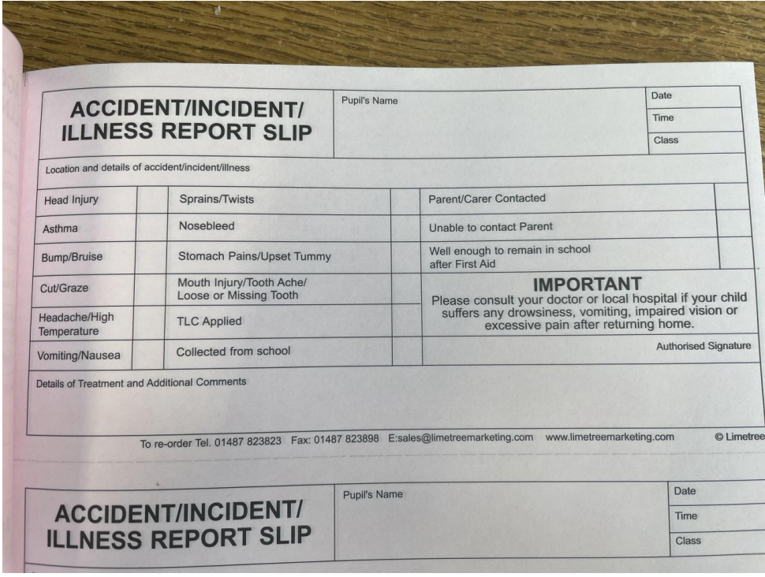

**Appendix 3 – First Aid Training Log**

|  |  |  |  |
| --- | --- | --- | --- |
| **Name/type of training** | **Staff who attended** | **Date attended** | **Date for training to be updated (where applicable)** |
| Paediatric First Aid | Tracey Gaskin | May 2021 | May 2024 |
| Paediatric First Aid | Paula Cutts | May 2021 | May 2024 |
| Paediatric First Aid | Karen Caldwell | Dec 2021 | Dec 2024 |
| Paediatric First Aid | Lynn McGrath | Jan 2022 | Jan 2025 |
| Paediatric First Aid | Claire Marriott | Nov 2023 | Nov 2026 |
| Paediatric First Aid | Sandra Evans | Feb 2024 | Feb 2027 |
| Paediatric First Aid | Zahia Milsom | Feb 2024 | Feb 2027 |
| Paediatric First Aid with Forest School element | Rose Swaden | March 2024 | March 2027 |
| Paediatric First Aid | Rachael Kite | Jan 2023 | Jan 2026 |
| Paediatric First Aid | Jackie Parker | Jan 2024 | Jan 2027 |
| Paediatric First Aid | Annabelle Brees | Jan 2024 | Jan 2027 |
| Paediatric First Aid | Emily Deacon | Feb 2024 | Feb 2027 |
|  |  |  |  |
|  |  |  |  |

|  |  |  |  |
| --- | --- | --- | --- |
| **The following staff will be undertaking First Aid at Work training shortly:** | | | |
| Paediatric First Aid with Forest School element | Jenny Sanders | June 24 |  |
|  |  |  |  |